A MINI PROJECT REPORT
ON
“Name of the Project Title”

Submitted in partial fulfilment of the
requirements for the award of the degree of

BACHELOR OF TECHNOLOGY
IN
COMPUTER SCIENCE AND ENGINEERING



Submitted By

1. Student Name 1 Roll No: 108250600263
2. Student Name 2 Roll No: 108250600245
3. Student Name 3 Roll No: 108250600210
4. Student Name 4 Roll No: 108250600244

Year: 1st, Section: IV, Semester: 1st

Academic Year
2025 – 2026

Under the Guidance of
Bikram Saha
Designation of the Guide

Department of Computer Science and Engineering
Asansol Engineering College

CERTIFICATE

This is to certify that the mini project entitled “Name of the Project Title” is a record of the genuine work carried out by the following students of B.Tech 1st Year, Department of Computer Science and Engineering, Asansol Engineering College:

1. Student Name 1 Roll No: 108250600263
2. Student Name 2 Roll No: 108250600245
3. Student Name 3 Roll No: 108250600210
4. Student Name 4 Roll No: 108250600244

under my supervision and guidance during the academic year 2025–2026, in partial fulfilment of the requirements for the award of the degree of Bachelor of Technology in Computer Science and Engineering.
This project work is original and has not been submitted previously, either in part or in full, to this or any other institution for the award of any degree, diploma, or certification.

The project demonstrates a sincere effort by the students to apply the fundamental concepts of C programming, including structures, functions, and file handling, to develop a real-world application.

Bikram Saha Monish Chaterjee
--------------------------------- ---------------------------------
Guide Name HOD Name
(Assistant Professor) (Head of the Department)
Department of CSE Department of CSE
Asansol Engineering College Asansol Engineering College

Date:

Place: Asansol, West Bengal

ACKNOWLEDGEMENT

We take this opportunity to express our sincere gratitude and respect towards our project guide, Guide Name, Assistant Professor, Department of Computer Science and Engineering, Asansol Engineering College, for his/her valuable guidance, constant encouragement, constructive suggestions, and continuous support throughout the successful completion of this mini project.

We are also thankful to the Head of the Department, HOD Name, Department of Computer Science and Engineering, for providing the necessary facilities, infrastructure, and academic environment to carry out this project work effectively.

We extend our sincere thanks to all the faculty members of the Department of Computer Science and Engineering for their guidance and cooperation during the course of this project.

Finally, we express our heartfelt gratitude to our parents and friends for their moral support, motivation, and encouragement, which played a vital role in the successful completion of this project.

- Name of Student 1 Signature: ________________________
- Name of Student 2 Signature: ________________________
- Name of Student 3 Signature: ________________________
- Name of Student 4 Signature: ________________________
- Name of Student 5 Signature: ________________________

5. Abstract
The Vehicle Service Management System (VSMS) is a comprehensive software solution designed to streamline the operations of vehicle service centers. Built using the C programming language, this system provides a robust Command Line Interface (CLI) for managing vehicle records, service history, and user authentication. It replaces traditional paper-based record-keeping with a digital, file-based approach, ensuring data persistence and quick retrieval. The system distinguishes between Admin and User roles, allowing for secure management of sensitive data while providing easy access for standard queries. Key technologies include C file handling (fwrite/fread), defining custom data structures, and an enhanced UI using ANSI escape codes for a professional look.

6. Introduction
In the modern automotive industry, efficient management of vehicle service records is crucial for customer satisfaction and operational excellence. Traditional manual methods—using paper registers or simple spreadsheets—are prone to errors, data loss, and inefficiency. Retrieving a specific vehicle's history from a stack of files can be time-consuming and frustrating.
The Vehicle Service Management System addresses these real-world problems by digitizing the entire process. It provides a centralized platform where vehicle details, owner information, and service histories are stored securely. By automating these tasks, the project minimizes human error, speeds up data retrieval, and ensures that service centers can focus on their core job—servicing vehicles—rather than managing paperwork.

7. Objectives
The primary objectives of developing this project are:
- 1. Digital Transformation: To convert manual record-keeping into a digital format for better longevity and accessibility.
- 2. Efficiency: To reduce the time required to add, update, and search for vehicle and service records.
- 3. Security: To implement a role-based access system (Admin vs. User) to specific sensitive operations (like deleting records) are restricted to authorized personnel.
- 4. User Experience: To demonstrate that a CLI-based application can be user-friendly and visually appealing through the use of structured menus and color-coded outputs.
- 5. Data Integrity: To ensure data is persistently stored and correctly retrieved using file handling mechanisms.

8. Software & Hardware Requirements

Software Requirements
- Operating System: Windows 10/11 (Architecture independent).
- Programming Language: C (Standard C99 or later).
- Compiler: GCC (GNU Compiler Collection) via MinGW or similar.
- IDE/Text Editor: VS Code, Code::Blocks, or any standard text editor.
- Terminal: Windows CMD or PowerShell (with ANSI support enabled).

Hardware Requirements
- Processor: Intel Core i3 or equivalent (Minimal computational power required).
- RAM: 512 MB or higher (Optimization allows it to run on low-spec hardware).
- Storage: < 50 MB for compiled binary and data files.
- Input/Output: Standard Keyboard and Monitor.

9. System Design
The system follows a modular design, ensuring that different functional areas are handled by specific components.

Program Flow
- 1. Initialization: The system initializes and checks for the existence of data files. If missing, it creates them (e.g., creating a default Admin user).
- 2. Authentication: The user is presented with a Login screen.
- 3. Role Determination: Based on credentials, the user is directed to:
  - Admin Menu: Access to Add/Update/Delete vehicles and services.
  - User Menu: Restricted access (Search/View only).
- 4. Operation: The user selects an option (e.g., "Add Vehicle").
- 5. Execution: The system performs the task, updates the binary files, and returns feedback (Success/Error).

Header Files Description
- auth.h: Defines the User structure and function prototypes for login/registration.
- vehicle.h: Defines the Vehicle structure and prototypes for CRUD operations on vehicles.
- service.h: Defines the Service structure and prototypes for managing service records.
- ui.h: Contains macros for UI colors and display helper functions.

Data Structures
User Structure (auth.h):
typedef struct { int user_id; char name[40]; char password[20]; int role; // 1 = Admin, 2 = User } User;
Vehicle Structure (vehicle.h):
typedef struct { char vehicleNo[20]; char ownerName[40]; char phone[15]; char model[30]; char type[10]; int year; } Vehicle;

10. Flowchart
1. Start
2. Display Welcome Screen
3. Login / Register
  - If Register -> specific logic -> Save to users.dat -> Back to Login.
  - If Login -> Input ID & Pass -> Check users.dat.
4. Decision: Is Valid?
  - No -> Error Message -> Retry.
  - Yes -> Check Role.
5. Decision: Role Type?
  - Admin: Show Admin Menu (Add Vehicle, View All, Add Service, Reports, etc.).
  - User: Show User Menu (Search Vehicle, View History).
6. Action Selection: User selects an option (e.g., Add Vehicle).
7. Process: Execute Function (e.g., addVehicle()) -> Write to File.
8. Output: Display "Success".
9. Loop: Return to Menu until "Exit" is chosen.
10. Stop.

11. Algorithm
Algorithm for addVehicle():
1. Start function.
2. Open vehicles.dat in append mode (ab).
3. Prompt user to enter Vehicle Number.
4. Check if Vehicle Number already exists?
  - If Yes -> Display "Error: Vehicle exists" -> Return.
  - If No -> Continue.
5. Prompt for Owner Name, Phone, Model, Year.
6. Store data into a Vehicle variable.
7. Write the variable to file using fwrite().
8. Close the file.
9. Display "Vehicle Added Successfully".
10. Stop function.

12. Implementation (Code Explanation)
The implementation utilizes standard C libraries heavily focused on File Handling and Structs.

Use of Structures
Structures (struct) are used to group related data. For example, a Vehicle struct holds all info related to a single car (Plate, Model, Owner). This makes reading and writing to files cleaner, as we can read/write the entire block of memory at once.

File Handling
- fopen(filename, "ab"): Used to open files in 'append binary' mode to add new records without erasing old ones.
- fopen(filename, "rb"): Used to read records.
- fwrite(&variable, sizeof(Type), 1, filePtr): Core function to save data.
- fread(&variable, sizeof(Type), 1, filePtr): Core function to read data.

Control Statements
- switch-case is used extensively for Menus to handle user choices cleanly.
- while(1) loops are used to keep the application running until the user explicitly selects "Exit".

Snapshots
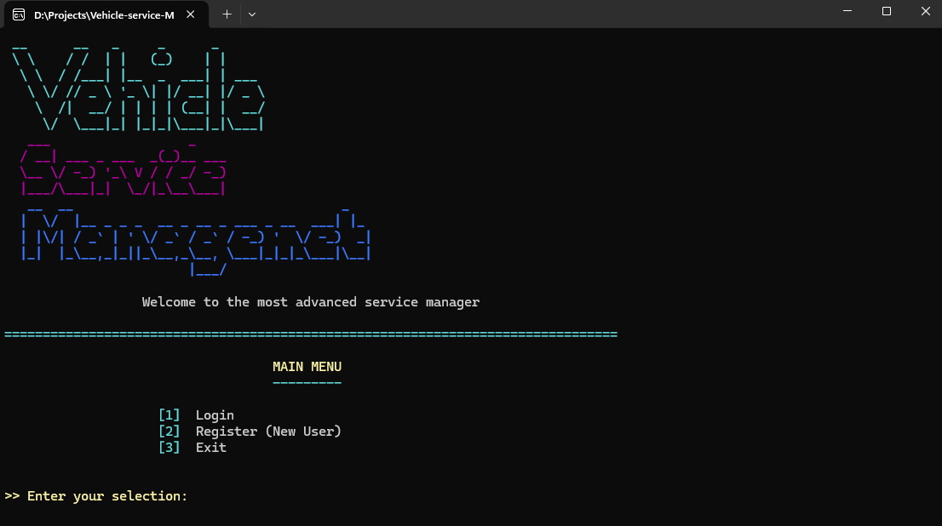

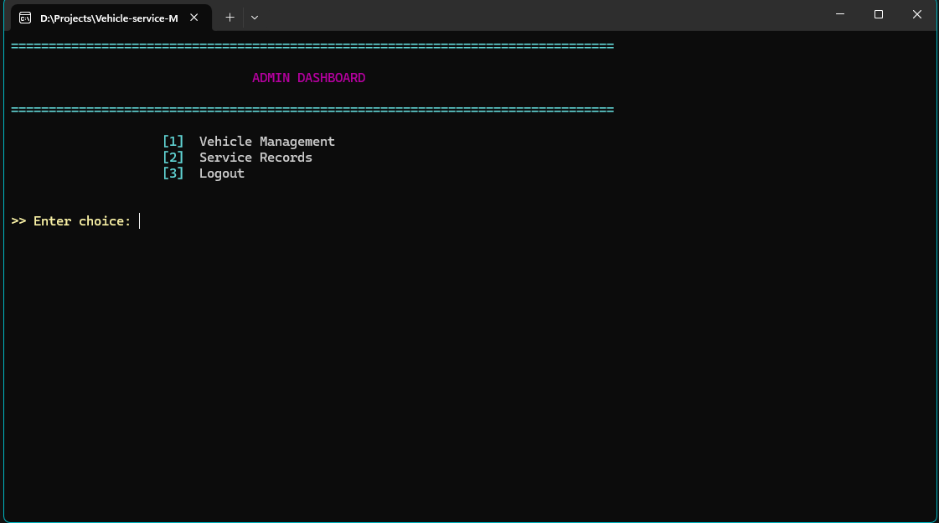
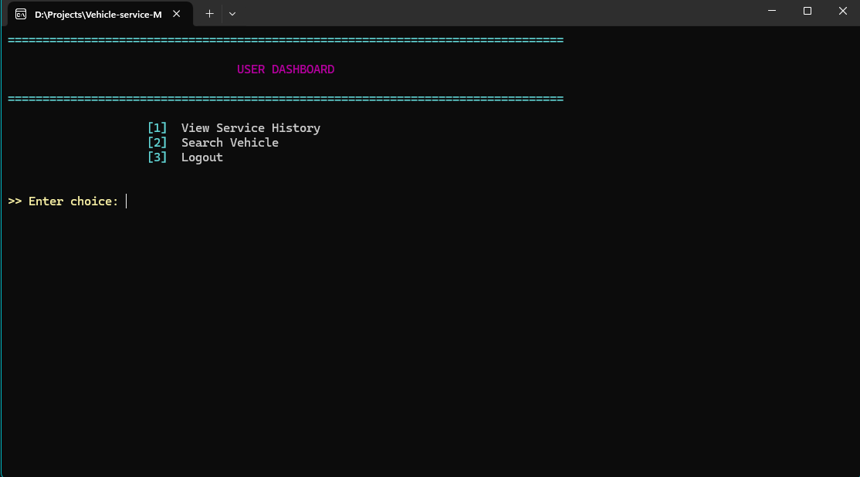

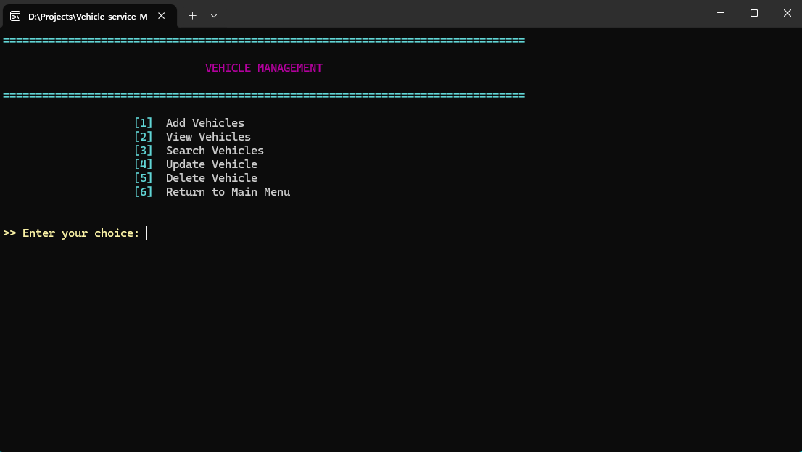

13. Advantages & Disadvantages

Advantages
- 1. Portability: The compiled .exe runs on any Windows machine without needing external database installation (SQL, etc.).
- 2. Resource Efficient: Consumes very little RAM and storage.
- 3. Data Persistence: Data is saved to files, so it survives system restarts.
- 4. Security: Basic authentication ensures only Admins can alter critical data.
- 5. Speed: Direct file access is faster for small-to-medium datasets compared to connecting to a remote server.

Disadvantages
- 1. Single User: Designed for a single terminal usage; multiple users cannot access the database simultaneously from different computers.
- 2. No Cloud Backup: If the local hard drive fails, data is lost (unless manually backed up).
- 3. CLI Interface: While functional, it lacks the graphical interactivity of a modern web or GUI app.

14. Conclusion
The Vehicle Service Management System successfully achieves its goal of digitizing service center records. It demonstrates the power of the C language in handling low-level file operations and building structured, logical applications. By implementing features like authentication, data validation, and persistent storage, the project serves as a practical tool for small service centers and a solid foundation for future enterprise-level enhancements.

15. Future Enhancements
- 1. GUI Integration: Upgrading from CLI to a Graphical User Interface (using C# or Python) for better user experience.
- 2. Database Migration: Moving from flat files (.dat) to a relational database like MySQL or SQLite for better scalability and complex querying.
- 3. Network Support: Enabling a Client-Server architecture so multiple employees can access the system simultaneously.
- 4. Invoicing: Adding a module to generate and print PDF bills for customers.

16. Bibliography/References
- 1. Kernighan, B. W., & Ritchie, D. M. (1988). The C Programming Language (2nd ed.). Prentice Hall.
- 2. "C File I/O," GeeksforGeeks. [Online]. Available: https://www.geeksforgeeks.org/basics-file-handling-c/
- 3. Vehicle Service Management System Source Code. (2025). GitHub Repository.
- https://gist.github.com/RabaDabaDoba/145049536f815903c79944599c6f952a

